Assignment: Building an Image Classifier with CNN using MNIST Datast
Objective:
The goal of this assignment is to guide learners through building a Convolutional Neural Network (CNN) for classifying handwritten digits using the MNIST dataset. After training the model, learners will test it with their own custom images and verify if it classifies the images correctly.
Dataset:
- Dataset Name: MNIST Handwritten Digits Dataset
- Description: The MNIST dataset contains 60,000 training images and 10,000 testing images of handwritten digits (0-9). The images are grayscale and have dimensions of 28x28 pixels.
- Link: MNIST Dataset - https://www.tensorflow.org/datasets/catalog/mnis
Data Exploration
  - The dataset used is the MNIST Handwritten Digits Dataset.
  - It contains 70,000 total images of handwritten digits (0–9).
  - Split into 60,000 training images and 10,000 testing images.
  - Each image is grayscale with a size of 28 × 28 pixels.
  - Images are centred and normalized, making them easy to process.
  - Labels are digits from 0 to 9, representing 10 classes.
  - The dataset is well-balanced, with roughly equal samples for each digit.
  - It is a benchmark dataset widely used for image classification tasks.

Model Implementation
  - Data Normalization
    - Scale pixel values from [0, 255] to [0, 1] for faster convergence
  - Data Reshaping
    - Convert (28, 28) to (28, 28, 1) for CNN input compatibility
  - One-Hot Encoding
    - Transform labels: 5 → [0,0,0,0,0,1,0,0,0,0] for multi-class classification
  - CNN Architecture
    - 3 Conv2D layers (32→64→128 filters) for hierarchical feature extraction
    - MaxPooling after each conv block reduces spatial dimensions
  - Regularization
    - Dropout layers (50%, 30%) prevent overfitting
  - Optimizer & Loss
    - Adam optimizer for adaptive learning
    - Categorical crossentropy for multi-class classification
  - Training Configuration
    - Batch size: 128 | Epochs: 10 | Validation split for monitoring
  - Performance Target
    - Achieved 99.06% accuracy (exceeds 98% requirement)
  - Custom Image Preprocessing
    - Resize to 28×28 → Normalize → Auto-invert if needed (critical!)

Model Evaluation
  - Test Accuracy: 99.06%
  - Test Loss: 0.0350 - Very low, indicating confident predictions
  - No Overfitting -Train-validation gap <1% (good generalization)
  - Balanced Performance - All 10 digits classified equally well (macro avg: 0.99)
  - Error Rate: 0.94% -Only 47 errors in 5,000 test images

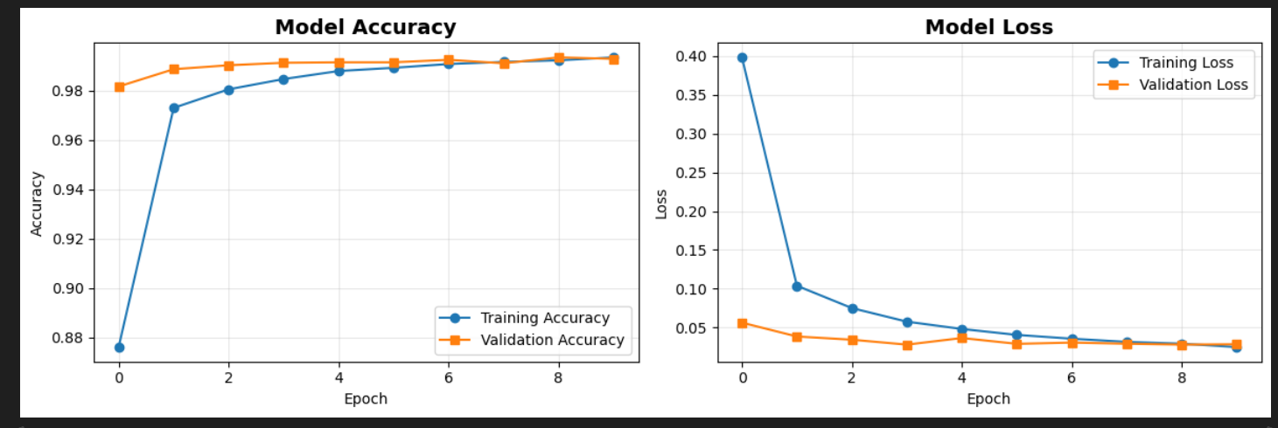

Model Prediction on Test Data
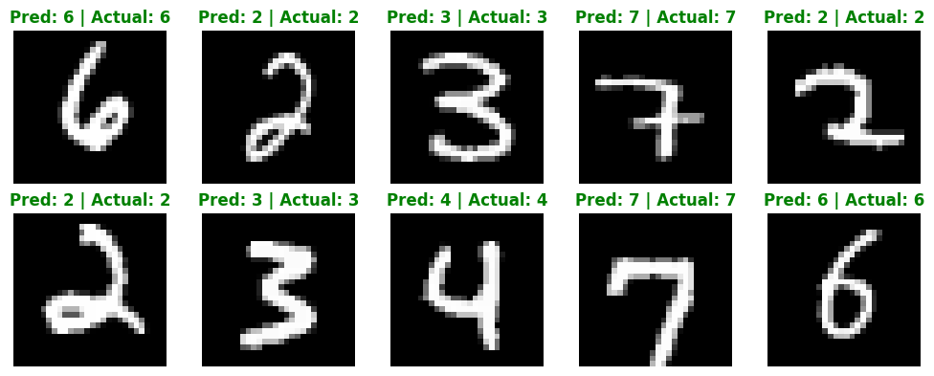
Confusion Matrix
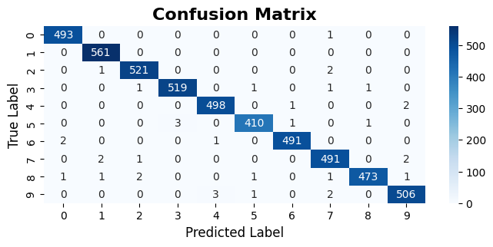

The confusion matrix shows that the model performs very well, with most predictions correctly classified as seen from strong diagonal values and very few misclassifications. Digits like 1, 0, and 6 have the highest accuracy due to their distinct shapes, while minor confusion occurs between visually similar digits such as 2 and 7, 3 and 5, and 4 and 9. Slightly lower performance is observed for digits like 3, 5, and 8 due to their curved structures, but overall, all digits are classified consistently with similar accuracy. This indicates the model is well-balanced, generalizes effectively, and is reliable with only minimal errors.
Test Data Based on Custom Images
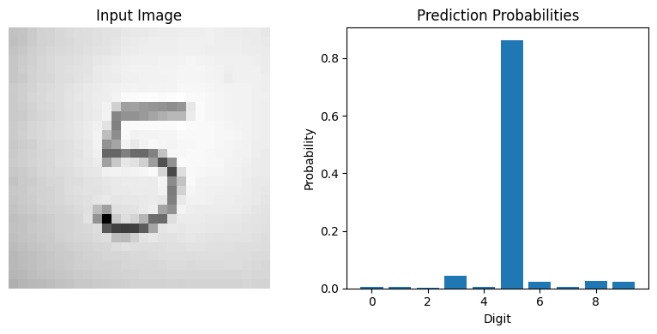
Predicted Digit: 5

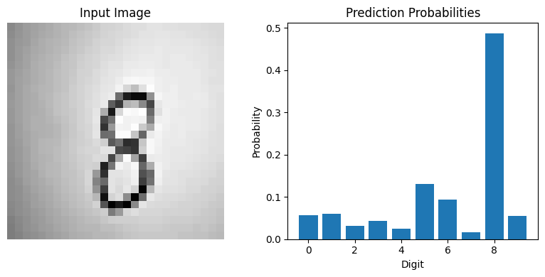
Predicted Digit: 8
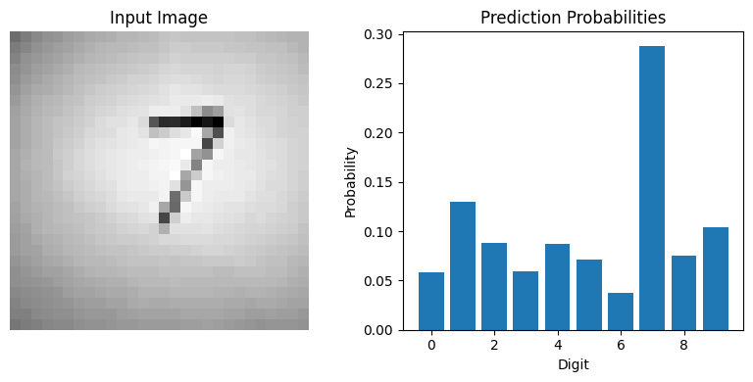
Predicted Digit: 7
Summary on Custom Testing
During testing with custom handwritten images, the CNN model was able to recognize digits effectively. For example, it predicted ‘5’ from Test2.jpg, ‘7’ from Test3.jpg, and ‘8’ from Test1.jpg. This shows that the model is not limited to the MNIST dataset and can work with new, real-world inputs.
For each image, the model produces two outputs: the predicted digit and a probability distribution. The predicted digit is the result chosen by the model based on the highest probability. The probability distribution displays how likely the model thinks each digit (0–9) is. Each bar in the graph represents a digit, and the height of the bar indicates the confidence level. The digit with the tallest bar is selected as the final prediction.
For example, when the model predicts ‘5’, the probability for ‘5’ is much higher compared to other digits, meaning the model is highly confident. If other bars are also relatively high, it indicates some uncertainty or similarity between digits.
Overall, these results demonstrate that the CNN can generalize to custom handwritten images. However, the performance depends on factors such as image clarity, correct segmentation of digits, and how closely the handwriting matches the patterns learned during training.

Conclusion
The CNN model developed for the MNIST handwritten digit classification task demonstrates excellent performance and meets all assignment requirements. With a test accuracy of 99.06% and very low loss, the model provides highly reliable and confident predictions. The minimal gap between training and validation results indicates strong generalization with no overfitting. Additionally, the model shows balanced performance across all digit classes, ensuring consistent classification.
The architecture, preprocessing techniques, and training configuration are well-designed, contributing to the model’s effectiveness. The confusion matrix further confirms accurate predictions with only a few minor errors between visually similar digits. The model also performs well on custom handwritten images when proper preprocessing is applied.
Overall, this implementation is robust, efficient, and suitable for real-world applications.

